ORDER FORM

Please enter the number of copies of the Body Corporate Law Handbook (Qld)

you would like to order: ________________ copies
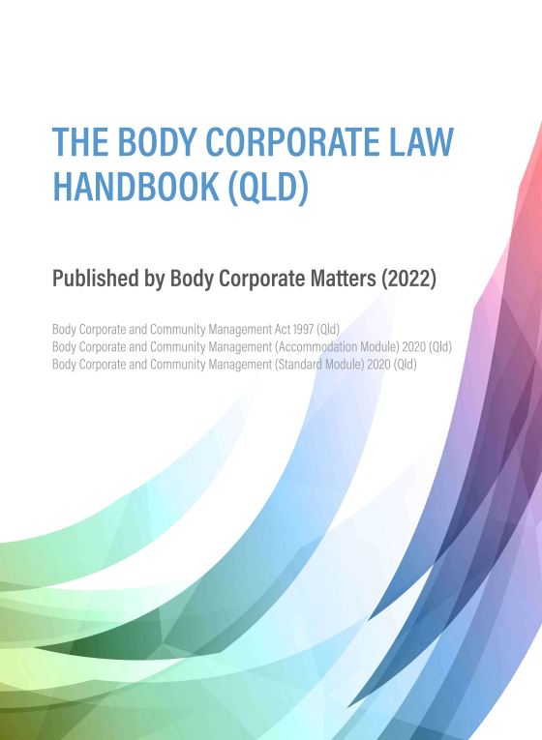
Price per handbook is $125 + GST = $137.50

Delivery fee
Cost of delivery is an additional $15 per book within Queensland.
For orders of multiple copies, we will confirm delivery cost on receipt of order form.

Your delivery details:

Your Name: __ _______________________________________

Delivery address: _____________________________________

Your phone no: _______________________________________

Your email: __________________________________________

_________________________________________________________________
Customer Signature Date

